Geometry Unit 5: Circles Name: __________________________________
5.1.0 Get Ready – Conic Sections Date: _____________________ Period: _______
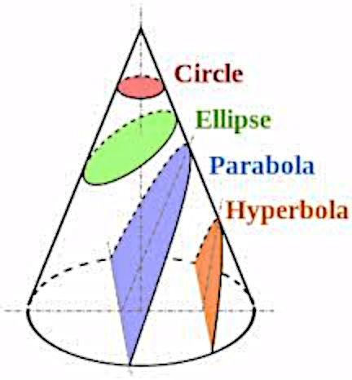
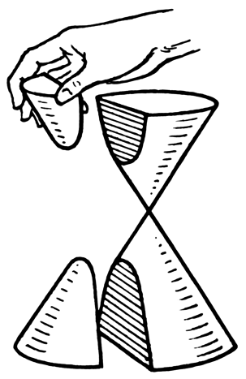
If you take a cone, and slice it in different ways, the slices have very different shapes, as shown in this diagram. The four shapes – circle, ellipse, parabola, and hyperbola – are known together as conic sections.
When we discuss conic sections, we really mean the parts of a double cone, so a hyperbola really has two parts, like this:

They show up in all sorts of places, as you see below. Identify each conic section.

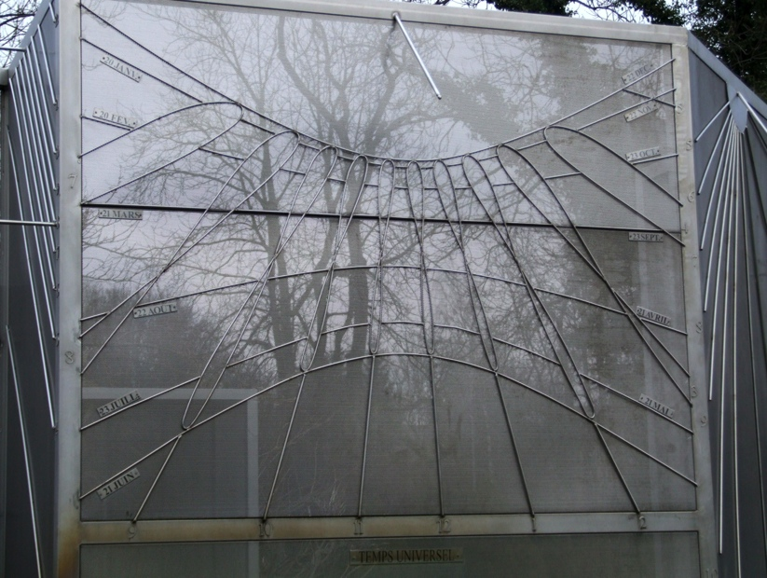
All photos from Wikimedia Commons

