Algebra 1 Unit 5: Scatter Plots & Trend Lines Name: _____________________________
5.2.1b Correlation Exploration Date: _________________ Period:______
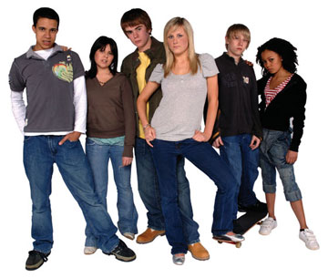
rogerfields.com
To explore the ways that two variables may be related, we are going to gather data about ourselves, graph the data, and look for trends that are evident in the graphs. We are going to look for a possible correlation (relationship) between several characteristics, or attributes, that we measure: height, arm span, hand span, index finger length, and distance from the top of your head to the ceiling, and a few that we simply record: the day of your birth date, and favorite number.

Which of these pairs of attributes do you think is most closely correlated?

Measure as necessary to the nearest 0.5 cm and record your results.

Name | Height | Arm Span | Hand Span | Distance - head to ceiling | Birth date | Favorite Number | Index Finger

We are going to use Fathom Dynamic Statistics Software to make several scatter plots of the data we have collected. Each group should enter their data in the table on my computer and we will make the graphs together.

The data that is in the “tightest” line shows the strongest correlation, or closest relationship. We say that the correlation is strong, weak, moderate or none depending on how tightly grouped around a line of best fit the data points are.

The two attributes are positively correlated if as one increases the other also increases (so the line of best fit would be going “uphill”). The two attributes are negatively correlated if as one increases the other decreases (so the line of best fit would be going “downhill”). We say the trend is positive or negative depending on whether the points are increasing or decreasing as we look from left to right.

1. Look at the graphs of the following pairs of attributes and describe the trends you see in the data.

a. Arm span and hand span
Trends: _____________________________________________

b. Height and arm span
Trends: _____________________________________________

c. Height and hand span
Trends: _____________________________________________

d. Distance from the top of one's head to the ceiling and height
Trends: _____________________________________________

e. Birth date and favorite number
Trends: _____________________________________________

f. Distance from the top of one's head to the ceiling and arm span
Trends: _____________________________________________

g. Hand span and index finger length
Trends: _____________________________________________

h. Height and birth date
Trends: _____________________________________________

We can actually measure how closely two attributes are correlated using Fathom, a graphing calculator, or a complicated mathematical formula. In order to see how “tightly” the points cluster about a line, we first construct a line of “best” fit. We are going to use a line called a least squares regression line. The software can then calculate a measure called the coefficient of determination, whose symbol is r². If two attributes are perfectly correlated, the data points will all lie on the same line and r² = 1. If two attributes are not at all correlated, the points won’t cluster around a line and r² = 0. Therefore, the higher the r² value, the better the correlation.

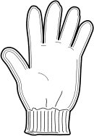
2. Suppose we found a giant glove in our classroom. We measured it and found that
the hand span was 40 cm and the index finger was 17 cm. Let’s find the equations
of the lines of best fit and the coefficient of determination for each of the pairs listed below.

a. Hand span and arm span
Equation: ______________________________________ r² = ______________

b. Hand span and height
Equation: ______________________________________ r² = ______________

c. Hand span and birth date
Equation: ______________________________________ r² = ______________

d. Hand span and distance from the top of one's head to the ceiling
Equation: ______________________________________ r² = ______________

e. Hand span and index finger length
Equation: ______________________________________ r² = ______________

f. Index finger and height
Equation: ______________________________________ r² = ______________

g. Index finger and birth date
Equation: ______________________________________ r² = ______________

h. Index finger and hand span
Equation: ______________________________________ r² = ______________

i. Which attributes have the strongest correlation?
The point of finding mathematical models, like lines of best fit, is to be able to use those models to make predictions about other data. We can use our equations to make some predictions about our classroom visitor. Show your work!

3. The hand span is _______ cm and the index finger is _______ cm. Now we can predict the visitor’s:

a. Arm span

b. Height

c. Birth date

d. Distance from head to ceiling

e. Index finger length

