Geometry 21 Unit 3: Area & Volume Name: _____________________________________
3.1.0 Get Ready – Kente Cloth Date: _______________________ Period: _______

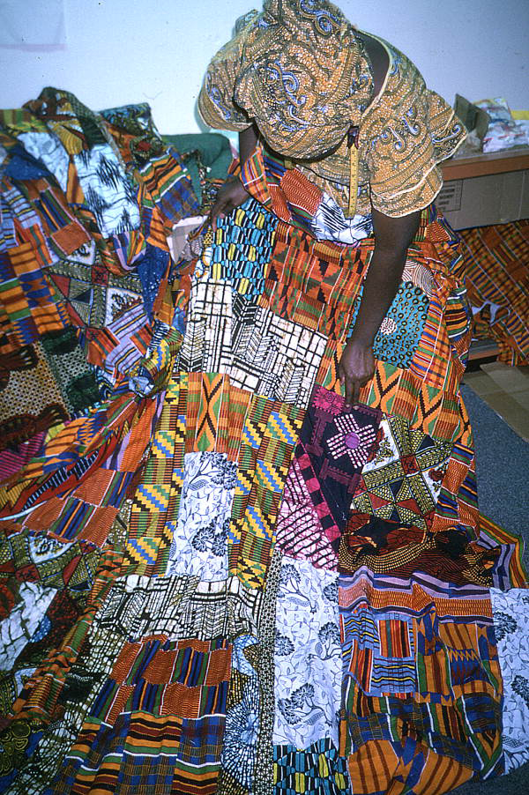
Asante weavers of Ghana convey history, philosophy, ethics, oral literature, moral values, codes of conduct and religious beliefs through ceremonial weaving of special patterns and colors called "Kente." Samples of Kente cloth date back to the 11th century -- 1000 years ago!
Kente cloth is hand woven on a horizontal loom. Strips about four inches wide are sewn together to make larger pieces of cloth. Yarn for the cloth is traditionally spun from cotton or silk. Various colors have different symbolic meanings (see below) and different combinations of silk, cotton, and colored yarn carry different levels of prestige.
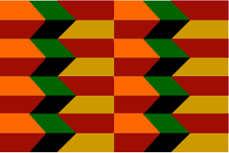

Clothing designer Abenaa Owusu showing her scrap quilt in 1990, Tallahassee, Florida

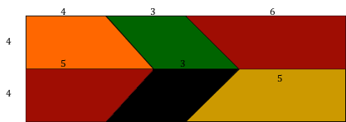
black -- maturation
blue -- peacefulness
green -- growth
gold – royalty
grey -- cleansing
maroon -- healing
pink -- mild, gentle
purple -- feminine
To make the fabric above, the weaver might first determine the area covered by each color. What shapes are in this cloth? What is each area?
Design your own Kente pattern.
http://kente.midwesttradegroup.com/history.html

red – bloodshed, politics
silver -- serenity, purity
white – purification
yellow -- preciousness

