Geometry Unit 5: Circles and Other Conics Name: _______________________________
5.2.0 Get Ready – Photo File Sizes Date: _________________ Period:________
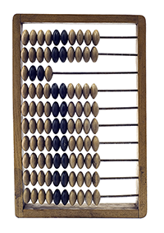
Mrs. Silverman was editing photos (again) to use in her math lessons. She couldn’t decide exactly how big to make one of the photos, so she tried several different sizes. She wanted to be sure that the photo was big enough in its dimensions, but not too big in its file size. She tried a bunch of sizes and saved them as files named by the width in pixels*. When she went to open one of the files, this is what she saw:
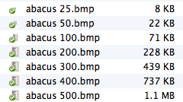


Of course, being mathematically curious, she began to wonder if there was a pattern to the file size, based on the photo’s pixel width. Make a table and a graph to see if she’s on to something.
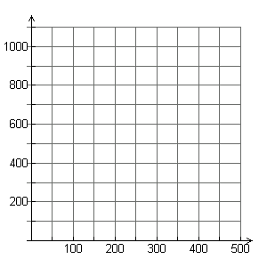
Width in Pixels
File Size in KB
On the back, describe the pattern.
Width in pixels | File size in KB
25
50
100
200
300
400
500 | 1100
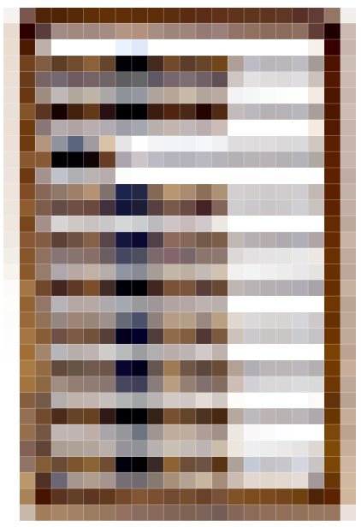
Is it linear? Is it exponential? How do you know?

*Pixels are little squares of color that make up an image, like this:

