Algebra 1 Unit 5: Scatter Plots & Trend Lines Name: _____________________________
5.2.0b Get Ready – Reading a Ruler Date: _________________ Period:______

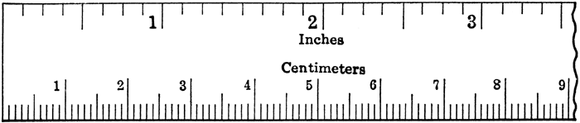
The markings on a standard ruler (in inches) divide each inch into 8 or 16 parts. The lines are different lengths to help you identify sixteenths, eighths, quarters, and halves more easily.
⅛ ¼ ⅜ ½ ⅝ ¾ ⅞
l
l
0.5 1 1.5 2 2.5

The markings on a metric ruler (in cm) divide each centimeter into 10 parts,
called millimeters. Usually, the 5 mm line is longer so you can more easily
identify 0.5 cm.

Measure each image to the nearest eighth inch and the nearest mm (0.1 cm).

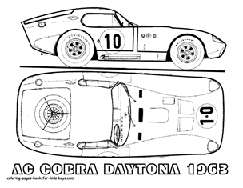

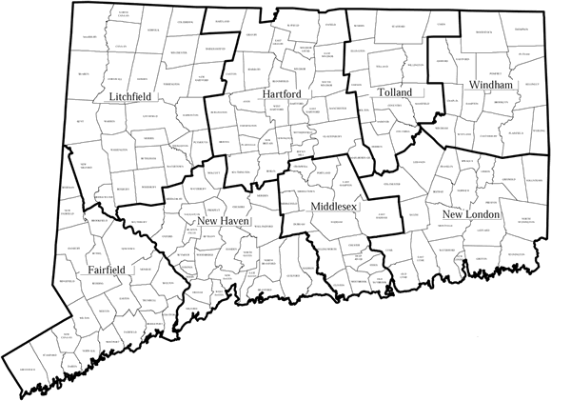
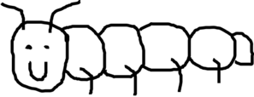

1. _______________ inches

_______________ cm

2. _______________ inches

_______________ cm

3. _______________ inches

_______________ cm

4. _______________ inches

_______________ cm

5. _______________ inches

_______________ cm
Images from bordonrealtyct.com and coloring-pages-book-for-kids-boys.com

