Exploring the Golden Ratio
1. Open GeoGebra, and if you get a Perspectives window, choose Algebra and Graphics. If your Algebra panel is off, turn it on by checking it in the View menu.
2. Use the new point tool to plot a point at the origin. 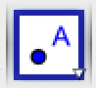
3. Select the Insert Image tool. 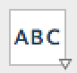 → 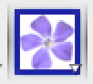 Click on the point you plotted; a window opens for you to choose an image. Select the rectangle you chose.
4. To scale the photo and attach it to the grid, you must specify at least one more vertex. Right click on the image and select Object Properties → Position. Type (8,0) for Corner 2. Plot a point at (8,0).
4. (Chrome) When the picture is imported, it will have two blue points at the bottom vertices. Drag the left one to (0, 0) and the right one to (8,0).
5. Zoom in to the top left corner of the image using the Move Graphics and Zoom tools. 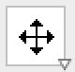 → 
6. Plot a point at that corner, on the y-axis, using the Point on Object tool. → 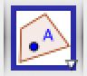
7. Draw a line ⊥ to the y-axis through the upper left (UL) vertex by selecting the ⊥ line tool 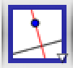, the point, and then the y-axis (*click outside of the image!). Now draw a line ⊥ to the x-axis* through (8,0).
8. Select the Compass tool. 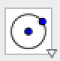 → 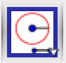 Click on the origin, the UL vertex, and the origin again.
9. Select the Intersection tool. →  Click on the circle and then the x-axis* to find the intersection.
10. Draw a line ⊥ to the x-axis* through the point of intersection you just found in step [12].
11. Select the Midpoint tool. →  Click on the origin and then the point of intersection from [12].
12. Use the intersection tool to find the point called F in my picture.
13. Select the segment tool. 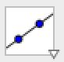 → 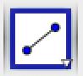 Construct GF.
14. Use the compass to construct a circle of radius GF, centered at G.
15. Where did your circle intersect the x-axis compared to point C?
16. What does that mean?
17. How close were you?

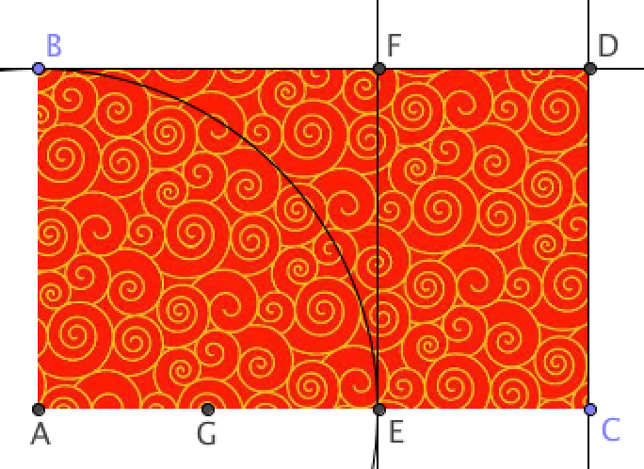
You should be here:

