TMC13 GeoGebra Activity: Jennifer Silverman

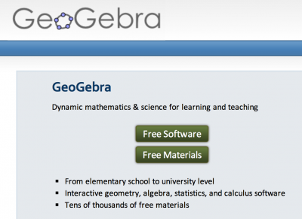
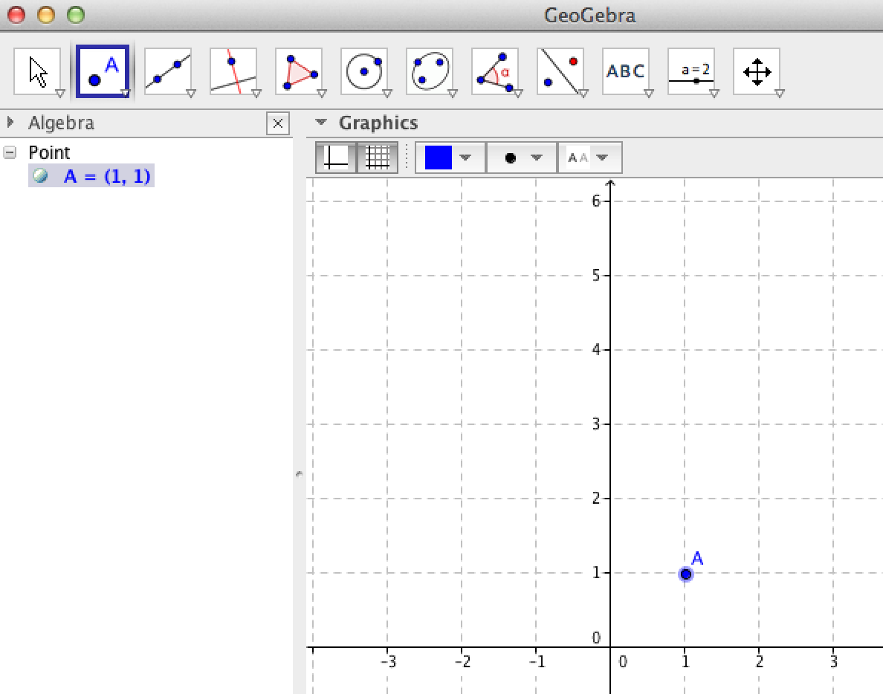
Go to GeoGebra.org and click on Free Software. Choose your platform and download the appropriate program. If you are on a Chrome Book, iPad, or other mobile device, the program might open automatically. You won’t have quite the same layout, and some of the commands are not in menus; you will have to type them in the input bar.

    - Open the program, and if you get a Perspectives window, choose Algebra and Graphics. If you don’t get that window, it is likely you already have the right view. It should look like the one below. If your Algebra panel is off, turn it on by checking it in the View menu.

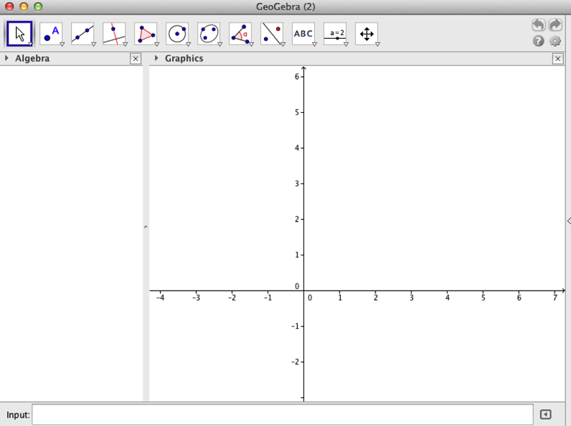

    - Turn on the grid by clicking on this arrow and then the grid. 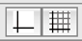

    - We need to plot a point to place our photo. I don’t use the origin, since I may want to move the image and it will be harder to move if I place it on either axis. Select the New Point tool 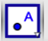 and click on the grid. I usually place a photo at (1,1); this will be the lower left corner of the image.

    - This is a good time to rescale the axes. I generally work in the first quadrant, and I like having the grid scaled by 1 as I work. You can always change it later. Use the Move Graphics tool 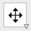 to shift and scale your grid.

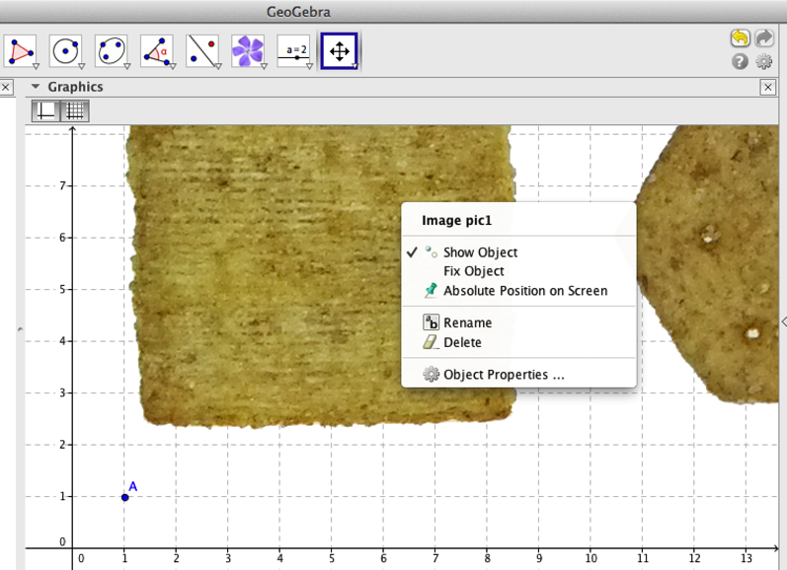
- Time for the photo! Click on the Insert Text tool 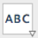. In the drop-down menu, choose the Insert Image tool. Click on point A and a window appears to browse for your photo – I chose our picture of four crackers.

- Wait…where are the rest of my crackers? To scale the photo and attach it to the grid, you must specify at least one more vertex. Since I may want to move the image, I will name coordinates in terms of point A. To specify the x-coordinate, name it x(A), and to specify the y-coordinate, name it y(A). I think I’ll make the whole image about 26 units long.
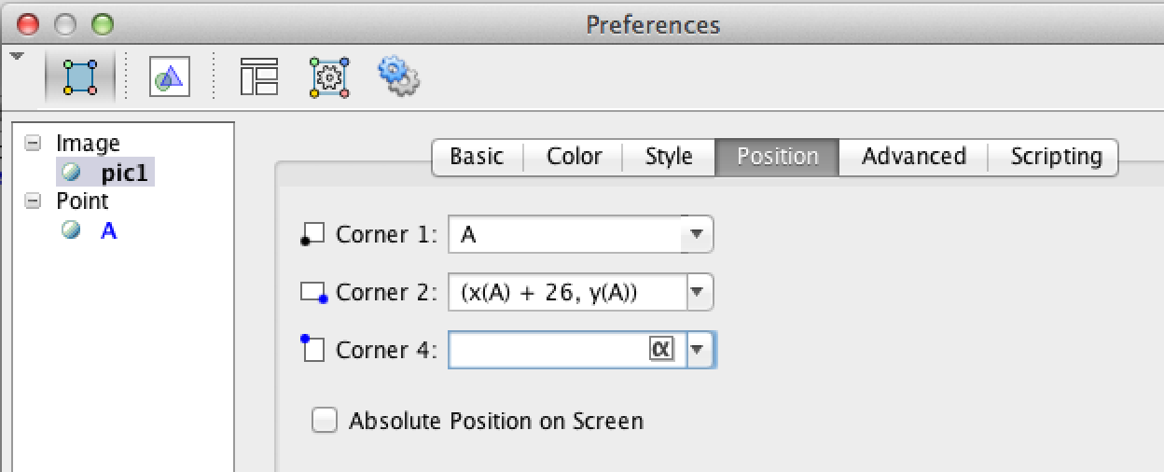
- Right click on the image to bring up its editing window (above) and choose Object Properties. Click on the Position tab, and specify the point for Corner 2, the lower right corner, with an x-value 26 greater than A’s and a y-value the same as A’s. Close that panel.
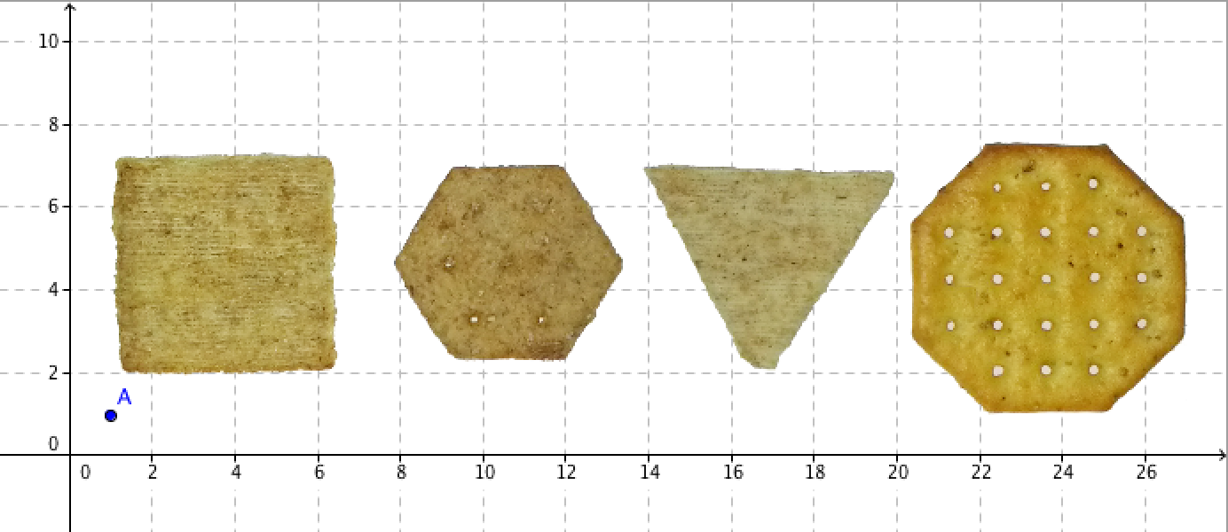
- Use the 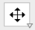 tool to adjust the window, and you should see the whole image!

- If you want to change the aspect ratio, enter coordinates for Corner 4 above or below the expected values.

Let’s explore other GeoGebra tools as we outline each cracker.
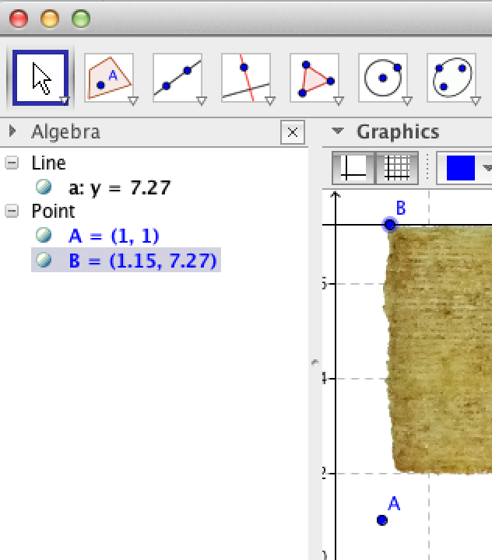
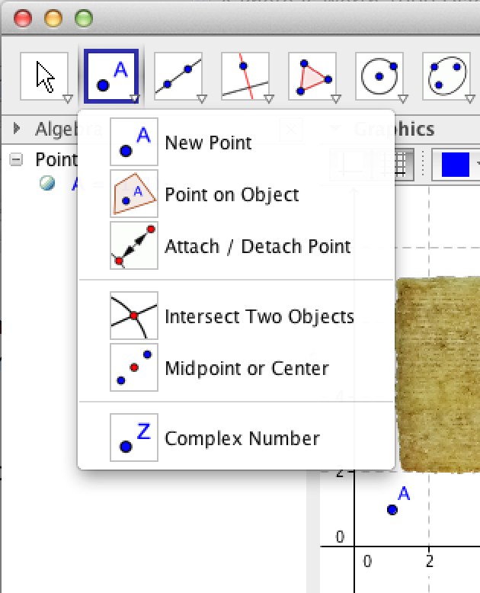
- Place a point on the corner of the cracker using the Point on Object tool 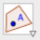. Select the Perpendicular Line tool 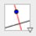, click on point(B), and then click on the y-axis. Select the Perpendicular line tool again, click on point(B), and then click on the x-axis.

- Use the Move tool to adjust the position of B and the lines.
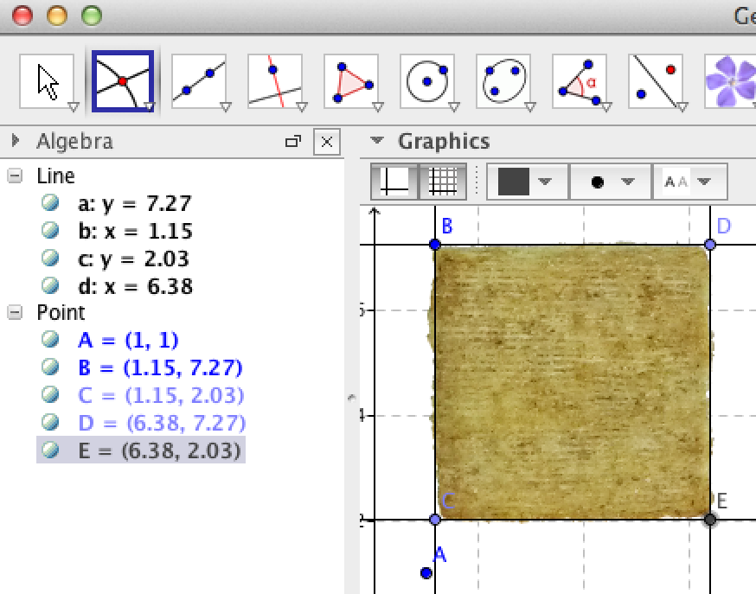
- Plot points C and D on the lines through B, at the corners of the cracker. Draw perpendicular lines through those points.

- Find the intersection of those lines by selecting the Intersect Two Objects tool 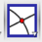 and clicking on each line.

- Hide point A by right clicking on it and unchecking Show Object. Select the Move tool and then select the lines in the Algebra panel by clicking on the first, holding shift, and clicking on the last. Right click on the selection and uncheck Show Object.

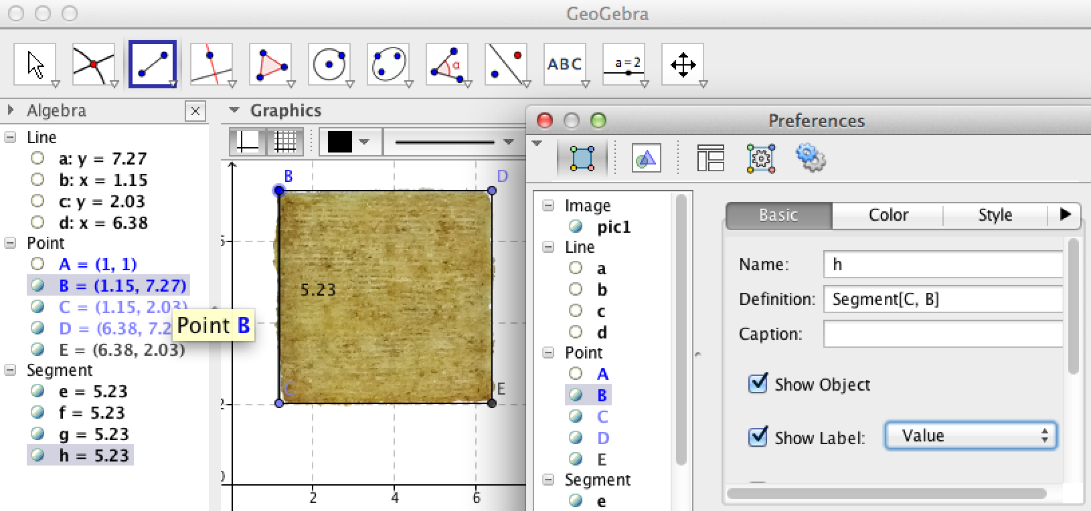
- Select the Segment Between 2 Points tool and then select each pair of points to draw the segments.

- Right click on each one, select Object Properties, check Show Label, and choose Value from the drop-down menu.

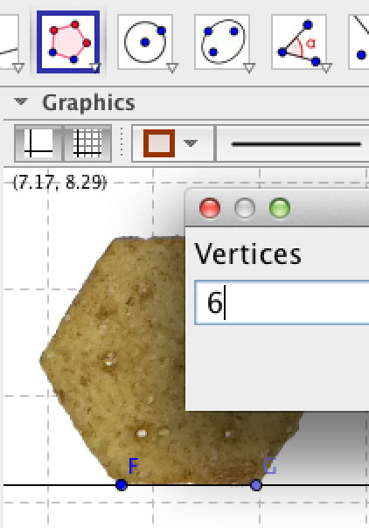
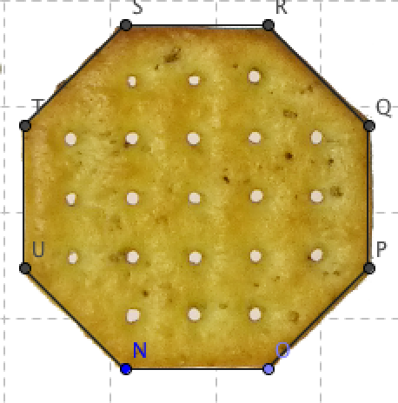
- For the hexagon, plot a point at the lower left corner and construct a line through it, perpendicular to the y-axis. Plot a point on that line at the lower right corner. Choose the Regular Polygon tool 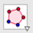, from the Polygon menu, and click on the two points. Type 6 in the box that pops up asking how many vertices you want. Click on the Move tool to adjust the points and align the hexagon with the cracker. Repeat this process for the octagon.

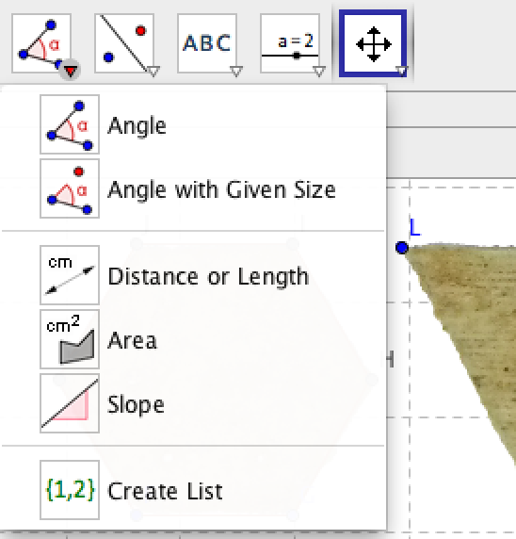
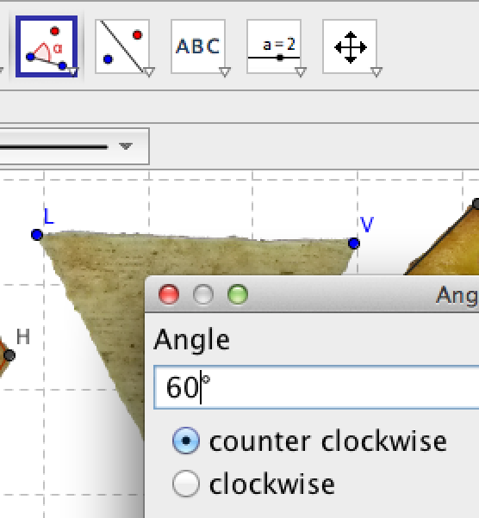
- For the triangle, I want to show you how to construct angles of a given size. Plot a point at the upper left corner and a point at the upper right corner. Draw a segment between the two points. Select the Angle With Given Size tool from the Angle menu. Click on the point on the left, and then the point on the right.

- Type 60 in the box asking for angle measure. GeoGebra constructs an angle marked by a point equidistant from the vertex. Use the points to draw a polygon.

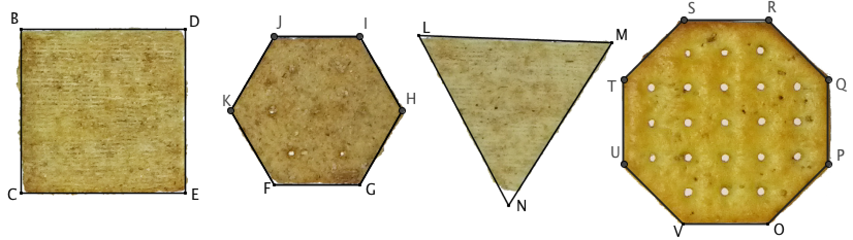
Time to address our problem. Here are our regular polygons, ready to have the appropriate elements added.

Here is a possible, but pretty boring, question.
1. Find the area of each cracker. We can use different tools for each, making it like an SBAC question.
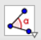
- For the square, I constructed a diagonal, added text to label it (including a square root symbol). Then I highlighted the segments in the Algebra panel and opened Object Properties, chose Decoration, and marked the sides congruent. Last, I chose an angle to mark as a right angle with the angle tool.

- For the hexagon, I found the center using two diagonals, constructed a perpendicular line, found the intersection, constructed the apothem, marked a right angle and an acute angle, and constructed segments from the center to two vertices to form a triangle.

- For the triangle I found the midpoints of each side with the Midpoint or Center tool 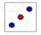, drew segments over the segments, highlighted them and marked them congruent, and constructed a midsegment.
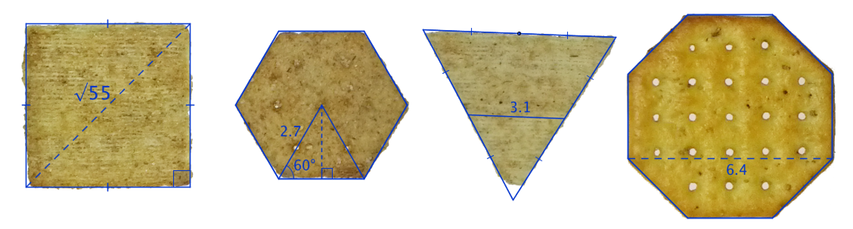
- For the octagon, I just constructed a segment.
Other possible questions:

